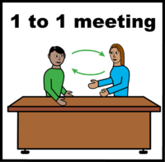 | Principles for Mending the Gaps in Annual Health Checks for people with learning disabilities in Somerset  These principles or ideas, are for people with learning disabilities and those supporting them with having Annual Health Checks
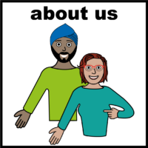 | - These ideas are for all people with learning disabilities including those with autism and Down’s syndrome.
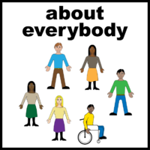 | - People with learning disabilities don’t want to be referred to as having different needs to ‘other’ people. Use positive language that is inclusive and promotes equality.
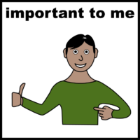 | 3. Going for an Annual Health Check is like going for half a pizza, people want a full pizza. Questions should not just focus on physical health. Annual Health Checks should be about the whole person and include mental health.
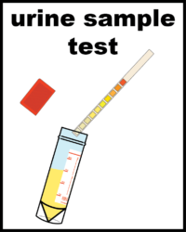 | 4. Don’t take the pee! Don’t ask people to provide urine samples and other results if they are not collected. It wastes people’s time.
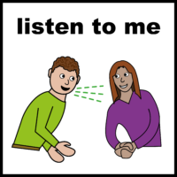 | - Some people with learning disabilities can talk about the health issues that are important to them. Some people may find it more difficult to talk about their health and need support.
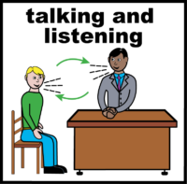 | - Annual Health Checks should be carried out face to face with pictures to support them. They should be online if it’s not possible to attend the surgery. They should never be over the telephone.
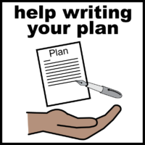 | - Where possible, people should be involved in agreeing their Annual Health Plan. It should be written down and based on health priorities they need to manage.
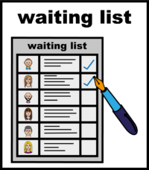 | - If possible, arrange with the person where and when it’s best for them to have their appointment and use number systems. It’s good to know where you are in the queue.
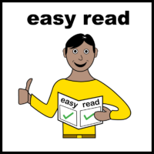 | - Support providers and GPs need to make sure everyone has access to easy read information about how Annual Health Checks work. There should be easy read information about physical and mental health conditions, and support.
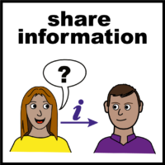 | - There may not be time to discuss all health needs, but the GP or nurse could help with signposting or referrals, such as mental health and well-being, and sexual health guidance.

These principles have been produced by people with learning disabilities in Somerset with The Open University. They used an approach called Mend The Gap. For more information about this, contact: Helen Casey, helen.casey@open.ac.uk
More information and help on supporting people with annual health checks can be found on the Registered Care Providers Association website: www.rcpa.org.uk
Acknowledgements to ‘easy on the i’, part of the Learning Disability Service at Leeds and York Partnership NHS Foundation Trust for the ‘easy-read’ symbols.
